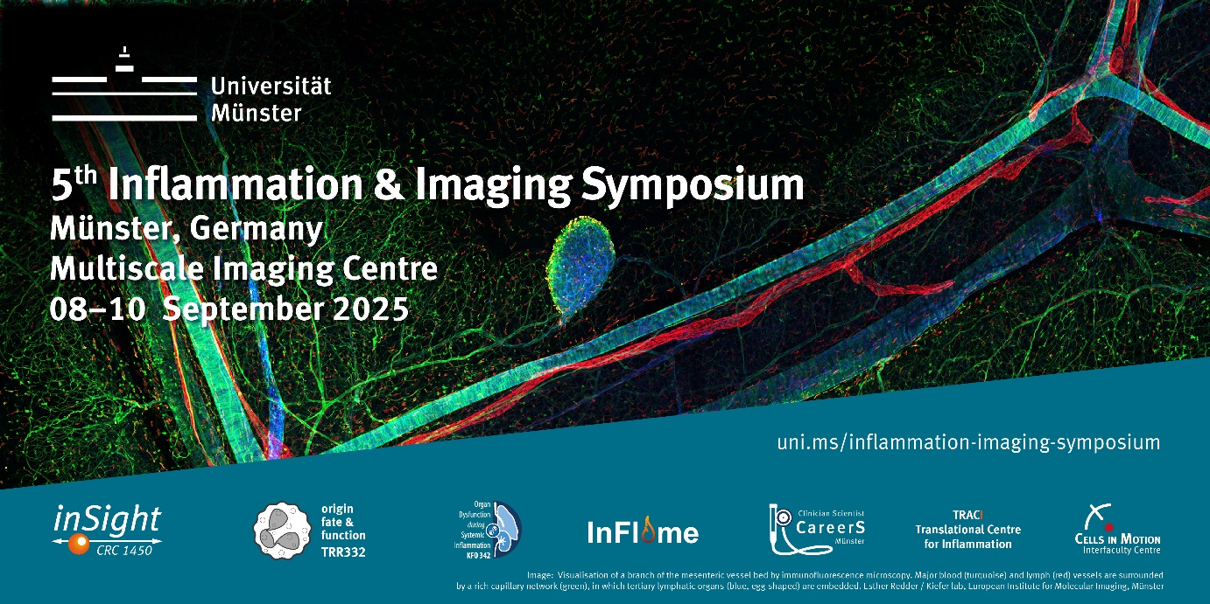

Please answer the following three questions that will help the conference organizers in the selection process and allocation of the available time slots.

1) Please indicate for which format you apply. Both options can be selected! (In case, your abstract can not be considered for an oral presentation, we will be happy to offer you a poster slot).
I would like to give a short talk (Yes/No):
I would like to present a poster (Yes/No):

2) What is your scientific background/discipline? (e.g. biologist, chemist, physician, computer scientist or mathematician,…)
*

3) Please indicate your career level and the time point when you started or defended your PhD. (e.g. doctoral researcher, postdoctoral researcher, MD student, junior group leader,…).
*

Title

Author 1, Author 2 [if applicable], Author 3 [if applicable], …., and [senior] Author

Affiliation University, Affiliation Institute/Department,
City, Country
Email Address First Author

The abstract should highlight major parts of the research explaining the importance of the work and include motivation/goals, methods, results and conclusions.
Abstracts should be no more than 200 words, formatted in Microsoft Word, and single-spaced, using size 12 Arial font. The poster title and author information is not part of the abstract body.
Include figures or illustrations and relevant references as appropriate.

