Spontaneous charge separation by drop motion across of a hydrophobic tube

Shaghayegh Saeidiharzand ¹, and Stefan A. L. Weber ^{1,2}, Denis Andrienko ²

¹Institute for Photovoltaics, University of Stuttgart, Pfaffenwaldring 47, 70569 Stuttgart, Germany.
² Max Planck Institute for Polymer Research, Ackermannweg 10, 55128 Mainz, Germany.

Charge separation at the moving interface of liquid-solid has been observed and studied through the years [1]. Water droplets impinging on a solid substrate [2,3], coalescence induced droplet jumping [4] and slide electrification [1,5] are among the phenomena which lead to voltage generation. It is shown that sliding water drops on hydrophobic insulating surfaces leads to charge separation at the three-phase contact line [1]. Dewetting velocity plays an important role in the amount of charge deposited at the receding contact angle [6]. Slide electrification is mainly studied through the drops motion on a tilted surface [7]. In this study, we make use of better control over parameters like drop velocity and drop contact time with the surface to investigate the influence of wetting kinetics on charge separation. Systematic measurements are carried out to quantify the amount of voltage generated by the drops motion and understand the governing mechanisms. Molecular dynamics simulations provide insight into how the non-equilibrium processes of charge separation are influenced by the surface chemistry, pH of water, and droplet velocity. Our findings on charge separation by dynamic wetting broaden the current insight into the liquid/solid interface and charge separation but also can be useful for possible future integration of slide electrification into energy harvesting systems.

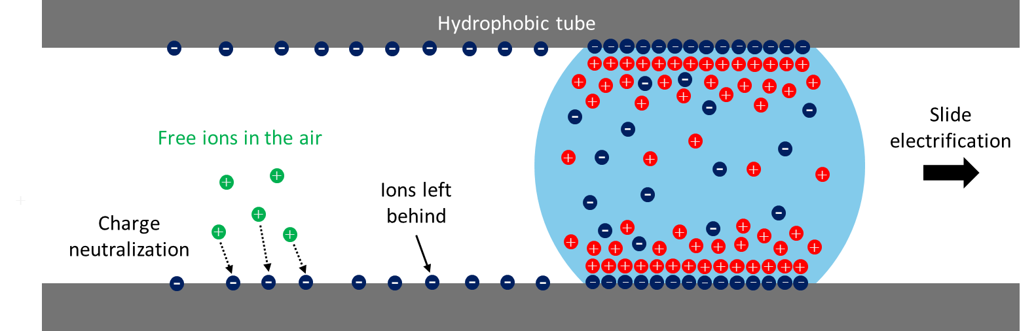
Figure 1. Schematic of charge separation as a result of drop motion across a hydrophobic tube.

References
[1] Leibauer B, Pop-Georgievski O, Sosa MD, Dong Y, Tremel W, Butt H-J et al. How Surface and Substrate Chemistry Affect Slide Electrification. J. Am. Chem. Soc. 2024;146(14):10073–83.
[2] Xu W, Zheng H, Liu Y, Zhou X, Zhang C, Song Y et al. A droplet-based electricity generator with high instantaneous power density. Nature 2020;578(7795):392–6.
[3] Wang L, Song Y, Xu W, Li W, Jin Y, Gao S et al. Harvesting energy from high‐frequency impinging water droplets by a droplet‐based electricity generator. EcoMat 2021;3(4).
[4] Miljkovic N, Preston DJ, Enright R, Wang EN. Electrostatic charging of jumping droplets. Nature communications 2013;4:2517.
[5] Stetten AZ, Golovko DS, Weber SAL, Butt H-J. Slide electrification: charging of surfaces by moving water drops. Soft Matter 2019;15(43):8667–79.
[6] Ratschow AD, Bauer LS, Bista P, Weber SAL, Butt H-J, Hardt S. How Charges Separate when Surfaces Are Dewetted. Physical review letters 2024;132(22):224002.
[7] Bista P, Ratschow AD, Stetten AZ, Butt H-J, Weber SAL. Surface charge density and induced currents by self-charging sliding drops. Soft Matter 2024;20(26):5045–52.

