**Spontaneous charge separation by drop motion across of a hydrophobic tube**

Alexander Raichle1, **Shaghayegh Saeidiharzand** 1, and Stefan A. L. Weber 1,2*

*1Institute for Photovoltaics, University of Stuttgart, Pfaffenwaldring 47, 70569 Stuttgart, Germany.2 Max Planck Institute for Polymer Research, Ackermannweg 10, 55128 Mainz, Germany.*

*\*e-mail: Stefan.Weber@ipv.uni-stuttgart.de, webers@mpip-mainz.mpg.de*

Sliding water drops on hydrophobic insulating surfaces leads to charge separation at the three-phase contact line [1]. Although slide electrification has been investigated thoroughly, understanding the exact mechanism is still a challenge. Electron transfer, formation of the electrical double layer structure, and adsorption of ions have been associated to this phenomenon [2]. Slide electrification is mainly studied through the drops motion on a tilted surface [3]. In this study, we make use of the better control over parameters like drop velocity and drop contact time with the surface to investigate the influence of wetting kinetics on charge separation. Furthermore, the effect of PH and salt concentration of water on slide electrification was explored. Our findings not only provide further insight into the charge separation mechanisms but also can be useful for possible future integration of slide electrification into energy harvesting systems.

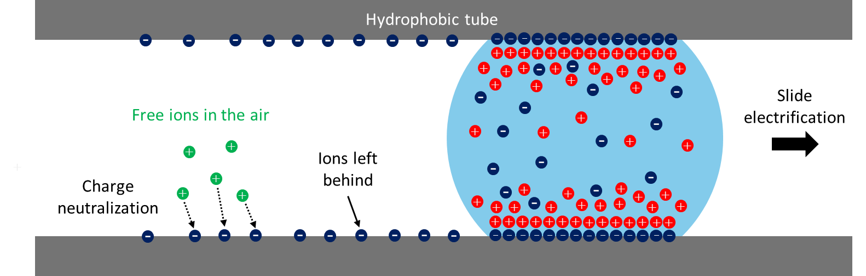

Figure 1. Schematic of charge separation as a result of drop motion across a hydrophobic tube.

[1] B. Leibauer *et al.*, "How Surface and Substrate Chemistry Affect Slide Electrification," *Journal of the American Chemical Society,* 2024.

[2] P. Bista, A. D. Ratschow, A. Z. Stetten, H.-J. Butt, and S. A. Weber, "Surface Charge Density and Induced Currents by Self-Charging Drops," *Soft Matter,* 2024.

[3] C. Hinduja, H.-J. Butt, and R. Berger, " Slide electrification of drops at low velocities," *Soft Matter,* 2024.